Objectives
smartGuard
Students | Wilson H. Bridges & Santiago Alzate | Spring
Students | Wilson H. Bridges & Santiago Alzate | 2019
Advisors | Dr. Bassem Alhalabi | 2019
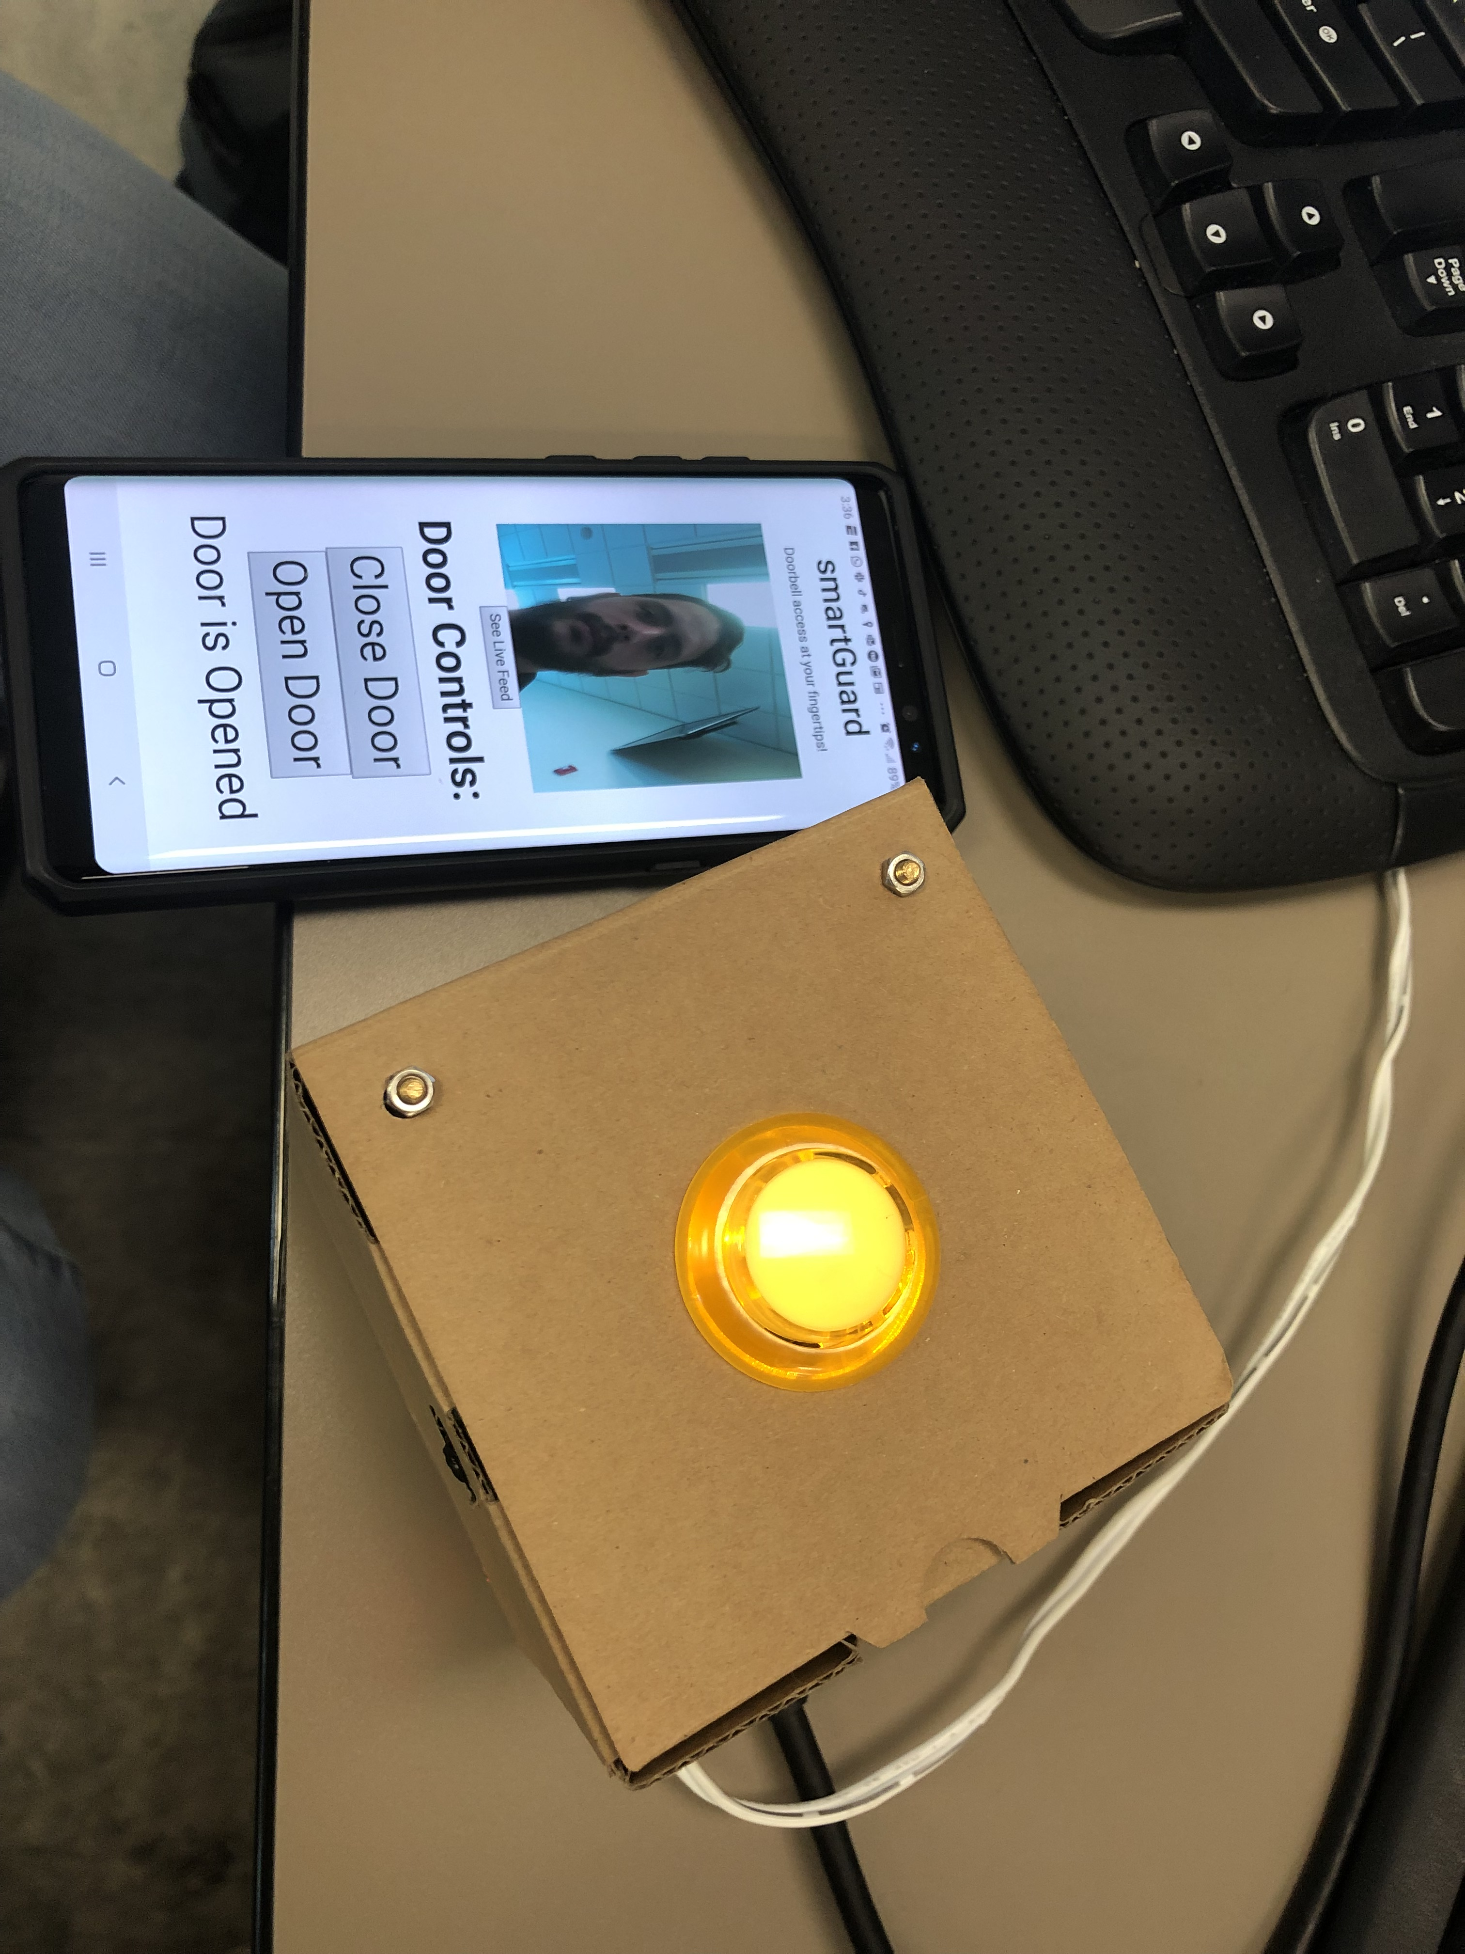
The purpose of this project was to create a low-cost solution to Door Alarm system. Our emphasis was on connectivity on the palm of your hands and safety for your home.
- We wanted to create a simple solution that will give home owners control of their home
- Visual connection of their entrance from anywhere and ability to lock and unlock door
- We also wanted to this project to be low cost, smart and simple enough for anyone to use

General Description
We used Google Assistant to give our prototype the ability to communicate with user. We also used Twilio API to send the home owner an alert that someone was at their door and the ability for the owner to unlock their door in case they recognized the person. We used Google Cloud Services’ facial recognition so that registered owners would walk up to their door and the door would unlock automatically. We handled this processing power using a Raspberry Pi3 since it’s powerful enough to handle our vision and also affordable enough to allow the average household to afford our product

Future Development
Our project is completely open sourced and will be available on Github soon. This will allow for others to make improvements to the project and grow the vision that we have. Also, we understand that new products and services are coming out every day and we want future generations to add those services to our product to make it better. We are also going to continue working on this product and move our authentication process from a local network based to a cloud-based solution. This would allow for diversification of connectivity from any network.

